SQL commands

create table phastaff(

PSID number primary key,

psfname varchar(20) not null,

pslname varchar(20) not null,

street varchar(30) not null,

state char(2) not null,

zip varchar(6) not null,

hidate date not null,

title varchar(20) not null,

salary number not null)

insert into phastaff(PSID,psfname ,pslname ,street ,state ,zip ,hidate ,title ,salary)

values(100, 'Scooby', 'Doooo', '3504 Broadway', 'NY', '10031', '10102010', 'clerk', 6000 )

alter table phastaff

add pscity varchar(15)

update phastaff

set pscity = 'New York'

where psid = 100

alter table phastaff

modify pscity not null

insert into phastaff(PSID,psfname ,pslname ,street ,pscity, state ,zip ,hidate ,title ,salary)

values(101, 'Raymond', 'Parker', '3276 Southern Street', 'Huntington' ,'NY', '11743', '12122012', 'cashier', 5500 )

insert into phastaff(PSID,psfname ,pslname ,street ,pscity, state ,zip ,hidate ,title ,salary)

values(102, 'Doug', 'Jackson', '1276 Kidd Avenue', 'HOLTSVILLE' ,'NY', '00501', '01012000', 'pharmacist', 8800 )

insert into phastaff(PSID,psfname ,pslname ,street ,pscity, state ,zip ,hidate ,title ,salary)

values(103, 'Carmen', 'Edward', '3330 Briercliff Road', 'Bronx' ,'NY', '10459', '01022005', 'pharmacist', 8200 )

insert into phastaff(PSID,psfname ,pslname ,street ,pscity, state ,zip ,hidate ,title ,salary)

values(104, 'Irma', 'Bobo', '855 Oak Street', 'Sandy Creek' ,'NY', '13145', '09222007', 'pharmacist', 8000 )

insert into phastaff(PSID,psfname ,pslname ,street ,pscity, state ,zip ,hidate ,title ,salary)

values(105, 'Pual', 'Sweater', '2500 Old Dear Lane', 'Poughkeepsie' ,'NY', '12601', '11232007', 'pharmacist', 7900 )

insert into phastaff(PSID,psfname ,pslname ,street ,pscity, state ,zip ,hidate ,title ,salary)

values(106, 'Shanna', 'Fox', '2617 Stanley Avenue', 'Hempstead' ,'NY', '11550', '11192013', 'pharmacist', 7100 )

insert into phastaff(PSID,psfname ,pslname ,street ,pscity, state ,zip ,hidate ,title ,salary)

values(107, 'Marganet', 'Holly', '2505 Dancing Dove Lane', 'New York' ,'NY', '10013', '05112014', 'pharmacist', 7400 )

insert into phastaff(PSID,psfname ,pslname ,street ,pscity, state ,zip ,hidate ,title ,salary)

values(108, 'Hollow', 'Omega', '153 Bottom Lane', 'Buffalo' ,'NY', '14216', '06162010', 'clerk', 6600 )

insert into phastaff(PSID,psfname ,pslname ,street ,pscity, state ,zip ,hidate ,title ,salary)

values(109, 'Joel', 'Wheeler', '201 Austin Avenue', 'HOLTSVILLE' ,'NY', '00501', '11112011', 'clerk', 6900 )

insert into phastaff(PSID,psfname ,pslname ,street ,pscity, state ,zip ,hidate ,title ,salary)

values(110, 'Justin', 'Hope', '3462 James Street', 'Rochester' ,'NY', '14616', '10192000', 'cashier', 9000 )

create table parent(

PPID number primary key,

ppfirst varchar(20) not null,

pplast varchar(20) not null,

ppstreet varchar(30) not null,

ppcity varchar(20) not null,

ppstate char(2) not null,

ppzip varchar(5) not null,

ppphone varchar(11) not null,

ppemail varchar(25) not null)

create table parentchild(

PTID number,

PPID number,

Foreign key (PTID) references patients(ptid),

Foreign key (ppid) references parent(ppid),

Primary key (ptid, ppid))

insert into patients( PTID, pfirst, plast, address, city, state, zcode, phone, email, pmid)

values(10, 'Alma', 'Ackerman', '1166 Forest Avenue', 'New York', 'NY', '10004', '646-888-3899', 'AlmaAckerman01@yahoo.com' , 100)

insert into patients( PTID, pfirst, plast, address, city, state, zcode, phone, email, pmid)

values(11, 'Fredrick', 'Anderson', '977 Stanley Avenue', 'Levittown', 'NY', '11756', '516-520-5392', 'FredrickAnderson@msn.com' , 100)

insert into patients( PTID, pfirst, plast, address, city, state, zcode, phone, email, pmid)

values(12, 'Diane', 'McClurg', '1340 Mount Tabor', 'Poughkeepsie', 'NY', '12603', '914-464-7066', 'DianeMcClurg@gmail.com' , 101)

insert into patients( PTID, pfirst, plast, address, city, state, zcode, phone, email, pmid)

values(13, 'Cristy', 'Arnold', '446 Graystone Lakes', 'HOLTSVILLE', 'NY', '00501', '478-453-7727', 'CristyArnold@gmail.com' , 102)

insert into patients( PTID, pfirst, plast, address, city, state, zcode, phone, email, pmid)

values(14, 'Brian', 'Swensen', '3262 Hoffman Avenue', 'Huntington', 'NY', '11743', '917-868-3291', 'BrianSwensen@gmail.com' , 103)

insert into patients( PTID, pfirst, plast, address, city, state, zcode, phone, email, pmid)

values(15, 'Richard', 'Bond', '363 Private Lane', 'BUFFALO', 'NY', '14227', '229-289-2822', 'RichardBond@yahoo.com' , 104)

insert into patients( PTID, pfirst, plast, address, city, state, zcode, phone, email, pmid)

values(16, 'Matthew', 'Labarbera', '1013 Golden Ridge Road', 'Schenectady', 'NY', '12305', '518-344-4963', 'MatthewLabera@yahoo.com' , 105)

insert into patients( PTID, pfirst, plast, address, city, state, zcode, phone, email, pmid)

values(17, 'Michael', 'Singletary', '1715 Pallet Street', 'Fairview Park', 'NY', '10603', '914-345-7329', 'MichaelSingle@gmail.com' , 106)

insert into patients( PTID, pfirst, plast, address, city, state, zcode, phone, email, pmid)

values(18, 'Rebecca', 'Carroll', '4521 Browning Lane', 'Binghamton', 'NY', '13901', '607-759-4526', 'RebeccaCarool@gmail.com' , 107)

insert into patients( PTID, pfirst, plast, address, city, state, zcode, phone, email, pmid)

values(19, 'Clay', 'Escobar', '1476 West Virginia Avenue', 'Albany', 'NY', '12204', '518-879-6522', 'ClayEscobar@aol.com' , 108)

insert into patients( PTID, pfirst, plast, address, city, state, zcode, phone, email, pmid)

values(20, 'Kathy', 'Padillo', '137 Abia Martin Drive', 'Long Island City', 'NY', '11101', '631-564-0365', 'KathyPadillo@aol.com' , 109)

alter table prescriptions

add psid number

alter table prescriptions

add foreign key(psid) references phastaff(psid)

alter table parent

modify ppphone varchar(12)

insert into parent( ppid, ppfirst, pplast, ppstreet, ppcity, ppstate, ppzip, ppphone, ppemail)

values(1, 'Andrew', 'Ackerman', '1166 Forest Avenue', 'New York', 'NY', '10004', '646-888-3890', 'AndrewAckerman@gmail.com')

insert into parent( ppid, ppfirst, pplast, ppstreet, ppcity, ppstate, ppzip, ppphone, ppemail)

values(2, 'Andrew', 'Anderson', '977 Stanley Avenue', 'Levittown', 'NY', '11756', '516-520-5392', 'AndrewAnderson@gmail.com')

insert into parent( ppid, ppfirst, pplast, ppstreet, ppcity, ppstate, ppzip, ppphone, ppemail)

values(3, 'David', 'Arnold', '446 Graystone Lakes', 'HOLTSVILLE', 'NY', '00501', '478-453-7728', 'DavidArnold@gmail.com')

insert into parent( ppid, ppfirst, pplast, ppstreet, ppcity, ppstate, ppzip, ppphone, ppemail)

values(4, 'Hitomi', 'Okita', '363 Private Lane', 'BUFFALO', 'NY', '14227', '229-289-0001', 'HitomiOkita@gmail.com')

insert into parent( ppid, ppfirst, pplast, ppstreet, ppcity, ppstate, ppzip, ppphone, ppemail)

values(5, 'Tasty', 'Escobar', '137 Abia Martin Drive', 'Long Island City', 'NY', '11101', '917-999-1748', 'TastyEscobar@gmail.com')

insert into parent( ppid, ppfirst, pplast, ppstreet, ppcity, ppstate, ppzip, ppphone, ppemail)

values(6, 'Norman', 'Gilbert', '3156 Hardesty Street', 'Albany', 'NY', '12207', '518-412-9343', 'NormalGil@gmail.com')

insert into parentchild(ptid, ppid)

values ( 10, 1)

insert into parentchild(ptid, ppid)

values ( 12, 1)

insert into parentchild(ptid, ppid)

values ( 11, 2)

insert into parentchild(ptid, ppid)

values ( 13, 3)

insert into parentchild(ptid, ppid)

values ( 16, 4)

insert into parentchild(ptid, ppid)

values ( 17, 4)

insert into parentchild(ptid, ppid)

values ( 18, 4)

insert into parentchild(ptid, ppid)

values ( 20, 4)

insert into parentchild(ptid, ppid)

values ( 14, 6)

insert into parentchild(ptid, ppid)

values ( 15, 5)

insert into parentchild(ptid, ppid)

values ( 19, 5)

insert into parent( ppid, ppfirst, pplast, ppstreet, ppcity, ppstate, ppzip, ppphone, ppemail)

insert into prescriptions(pid, nyspl, ptid, dop, did, refills, first, last, psid)

values(43, 'L100', 20, '12312010 125959', 290, 10, 'Kathy', 'Padillo', 110)

insert into prescriptions(pid, nyspl, ptid, dop, did, refills, first, last, psid)

values(42, 'L100', 19, '06252005 054427', 280, 3, 'Clay', 'Escobar', 109)

insert into prescriptions(pid, nyspl, ptid, dop, did, refills, first, last, psid)

values(41, 'L100', 18, '01252005 051227', 270, 3, 'Rebecca', 'Caroll', 108)

insert into prescriptions(pid, nyspl, ptid, dop, did, refills, first, last, psid)

values(40, 'B102', 17, '01252000 050222', 270, 3, 'Michael', 'Singletary', 107)

insert into prescriptions(pid, nyspl, ptid, dop, did, refills, first, last, psid)

values(39, 'B102', 16, '01252014 090919', 260, 1, 'Matthew', 'Labarbera', 106)

insert into prescriptions(pid, nyspl, ptid, dop, did, refills, first, last, psid)

values(38, 'B102', 15, '09192013 122111', 250, 1, 'Richard', 'Bond', 105)

insert into prescriptions(pid, nyspl, ptid, dop, did, refills, first, last, psid)

values(37, 'Q104', 14, '07152012 122111', 240, 2, 'Brian', 'Swensen', 104)

insert into prescriptions(pid, nyspl, ptid, dop, did, refills, first, last, psid)

values(36, 'Q104', 13, '02152012 113151', 230, 5, 'Cristy', 'Arnold', 103)

insert into prescriptions(pid, nyspl, ptid, dop, did, refills, first, last, psid)

values(35, 'Q103', 12, '10152012 113141', 220, 2, 'Diane', 'McClurg', 102)

insert into prescriptions(pid, nyspl, ptid, dop, did, refills, first, last, psid)

values(34, 'Q102', 11, '10152011 111111', 210, 2, 'Fredick', 'Anderson', 101)

insert into prescriptions(pid, nyspl, ptid, dop, did, refills, first, last, psid)

values(33, 'Q102', 10, '10102010 101010', 200, 1, 'Alma', 'Ackerman', 100)

alter table patients

add rank varchar(8)

update patients

set rank = 'Child'

where ptid < 22

update patients

set rank = 'Adult'

where ptid >= 22

delete from parentchild

where ptid = 18

update prescriptions

set psid = 103

where pid = 32

update prescriptions

set psid = 103

where pid = 21

update prescriptions

set psid = 104

where pid = 20

update prescriptions

set psid = 100

where pid = 31

update prescriptions

set psid = 106

where pid <=30 and pid >= 22

alter table phastaff

add pmid number

alter table phastaff

add foreign key(pmid) references pharmacies(pmid)

update phastaff

set pmid = psid

where psid = psid

update phastaff

set store = (select pharmacies.address

from pharmacies

where phastaff.pmid = pharmacies.pmid)

alter table drugs

add price number

update drugs

set price = 400

where did = 400

update drugs

set price = 190

where did >=330 and did <400

update drugs

set price = 170

where did >=290 and did <330

update drugs

set price = 150

where did >=240 and did <290

update drugs

set price = 123

where did >=200 and did <240

1. Identify the medication history of Clay Escobar. Display the patient name, parent names, physician, drug, date of prescription and dosage. Order chronologically by date.

select first || ' ' || last "Patient Name", ppfirst || ' ' || pplast "Parent Name", pfname||' '||plname "Physician", genename "Drug", dop "Date Of Prescription" , dosage

from prescriptions, parent, parentchild, prescribers, drugs

where first = 'Clay' and last = 'Escobar' and parentchild.ptid = prescriptions.ptid and parentchild.ppid = parent.ppid

and prescriptions.nyspl = prescribers.nyspl and drugs.did = prescriptions.did

order by dop

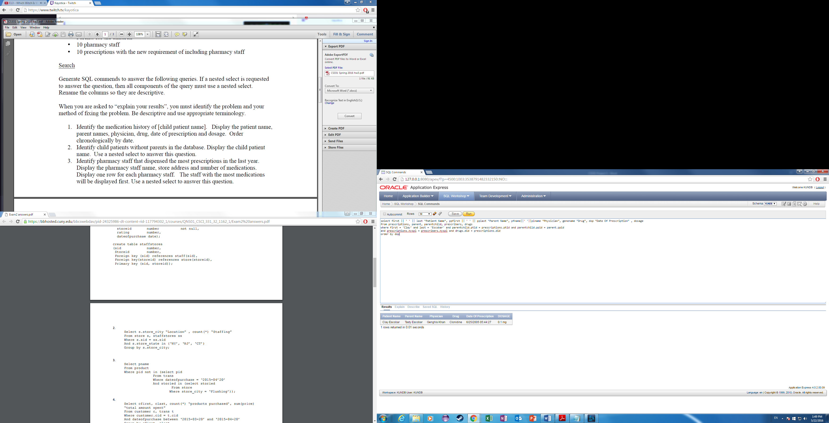

1. Identify child patients without partents in the database. Display the child patient name. Used a nested select to answer this question.

select pfirst || ' ' || plast "Child Patient Name"

from patients

where rank = 'Child' and PTID not in

(select ptid

from parentchild)

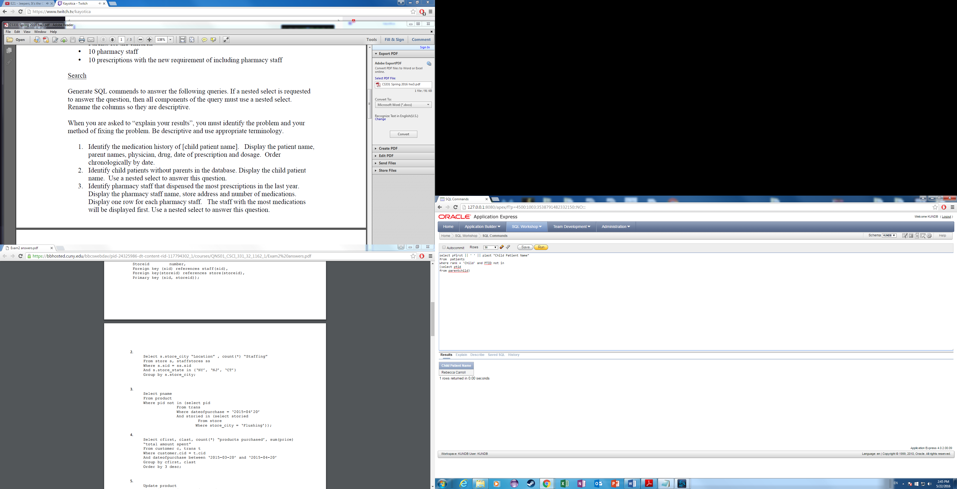

1. Identify pharmacy staff that dispensed the most prescriptions in the last year. Display the pharmacy staff name, store address, number of medications. Display on row for each pharmacy staff. The staff with the most medications will be displayed first. Used a nested select to answer this question.

select psfname|| ' ' || pslname "Staff Name", address "Store Address", count(1) "Number of Med"

from phastaff pa, pharmacies ph, prescriptions pres

where ph.pmid in(select pmid

from phastaff

where ph.pmid = pa.pmid and pa.psid = pres.psid and psid in (select psid

from prescriptions

where pres.psid = pa.psid and dop >= '04222015'))

group by psfname|| ' ' || pslname, address

order by count(1) desc

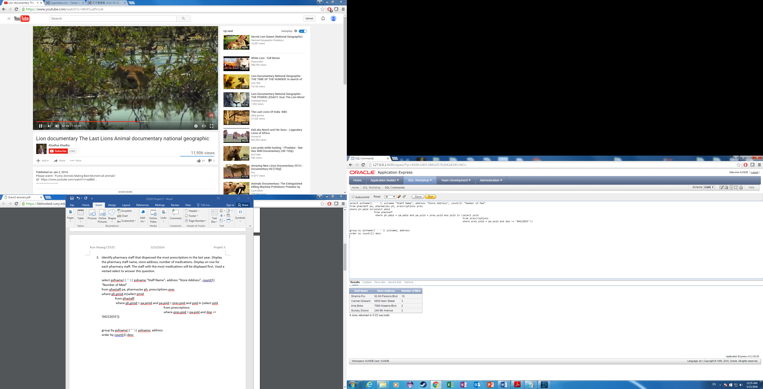

1. Identify pharmacies with more than three staff. Display the store name and

number of staff. Display one row for each store. The store with the most staff will

be displayed first.

select address, count(1) "Number of Staff"

from phastaff, pharmacies

where phastaff.pmid = pharmacies.pmid

having count(1) > 3

group by address

order by count(1) desc

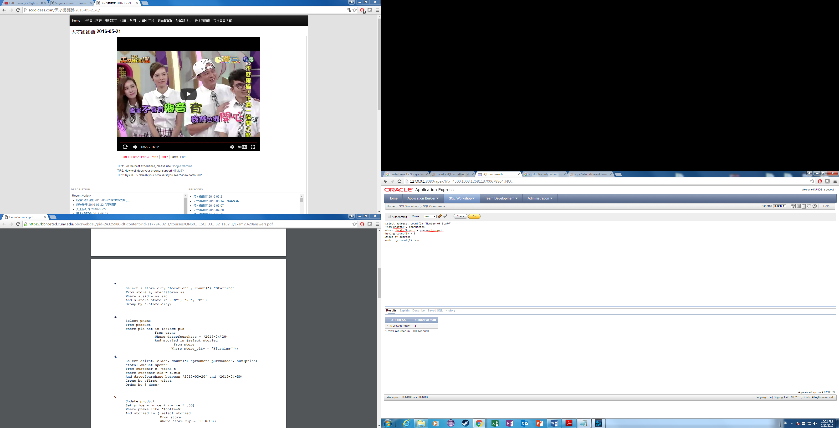

1. Identify stores with the most sales in 2016. Display one row for each store.

Display the store address, city, total revenue, smallest sale and largest sale. Use

functions to answer this question. The store with the highest revenue will display

first.

select address, city, sum(price) "Total Revenue", min(price) "Smallest Sale", max(price) "Largest Sale"

from pharmacies pha, phastaff ps, prescriptions pre, drugs dr

where pre.psid = ps.psid and ps.pmid = pha.pmid and pre.did = dr.did

group by address, city

order by sum(price) desc

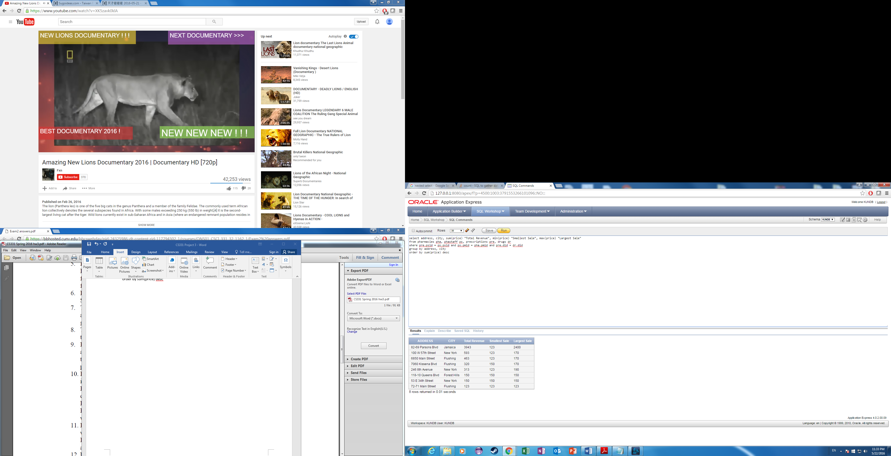

This is the price after I increase the price by 600%. I forgot to rename the columns so I went back to change it.

1. Increase the price of Omeprazole by 600% at all stores. Identify the sql commands to perform this operation.

update drugs

set price = price \*6

where genename = 'Omeprazole'

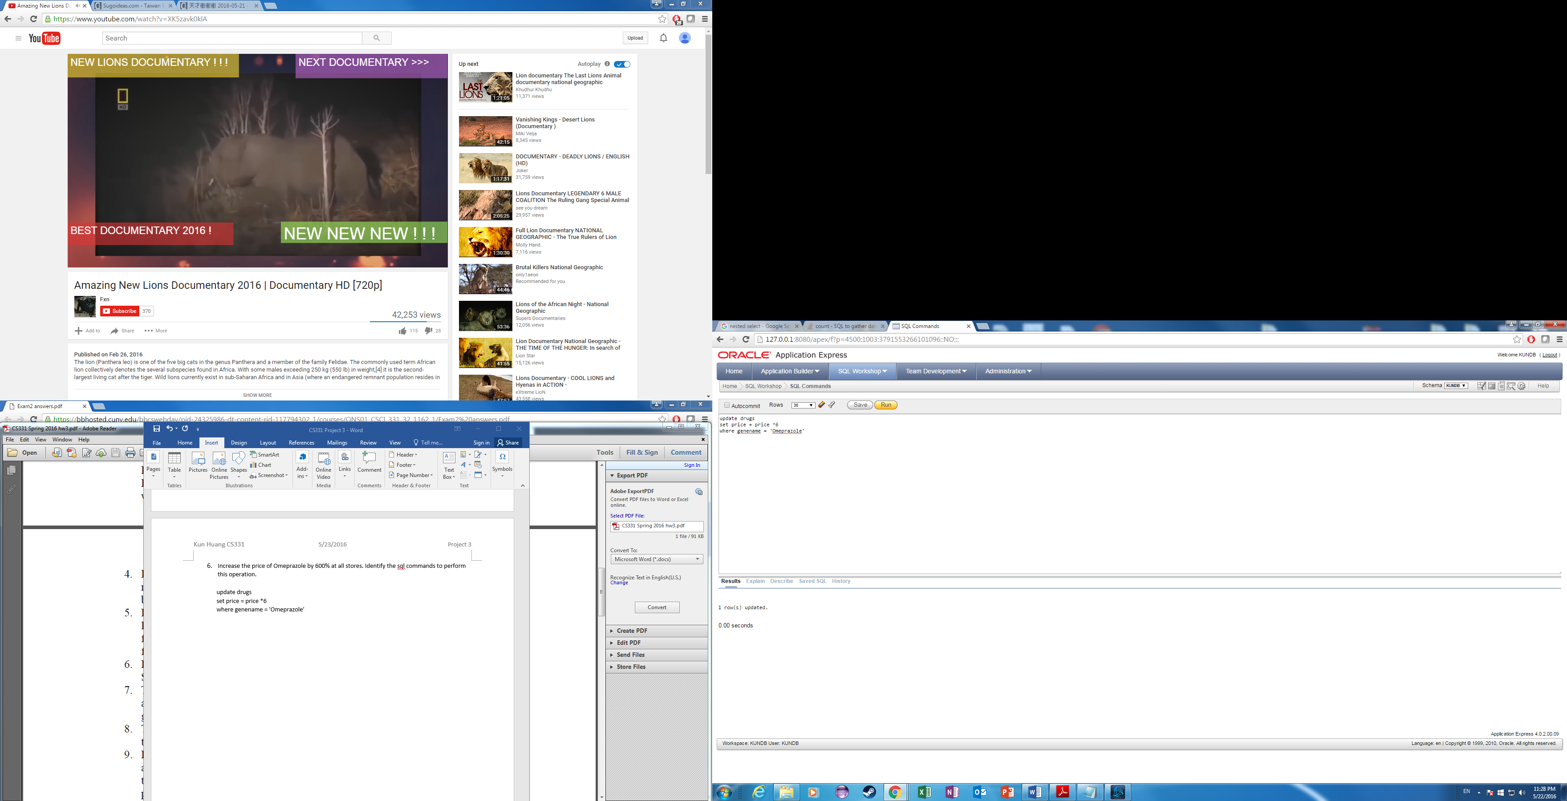

1. The pharmacist doesn’t know how to spell a drug name, but the first few letters are hydro. Identify all drugs with similar spelling. Display the brand name, generic name and dosage.

select brandname, genename, dosage

from drugs

where genename like 'Hydro%'

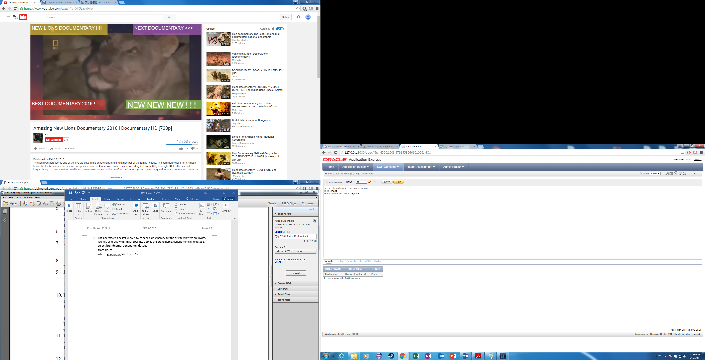

1. The drug Hydrochlorothiazide will no longer be sold at all stores. What is the best process to implement? Identify the SQL commands to perform this operation.

The best way to implement this would be to create a inventory for each store and column status to say if the drug is available at the store.

Create table storeinventory(

PMID number,

DID number,

Foreign key(PMID) references Pharmacies(PMID),

Foreign Key(DID) references Drugs(DID),

Primary Key(PMID, DID)

Available char(3) not null

)

Update storeinventory

Set availavle = ‘Yes’

Update storeinventory

Set available = ‘NO’

Where DID = 300 (300 is the DID of Hydrochlorothiazide)

1. In one SQL window, change the staff salary for record 1. Don’t commit. In another SQL commands window, change the staff salary for record 1. Don’t commit. Resolve the problem. Disable auto commit flag at the top of the windows before performing this operation. Explain your result.

The 2nd SQL commands windows gets stuck at SQL statement running…….

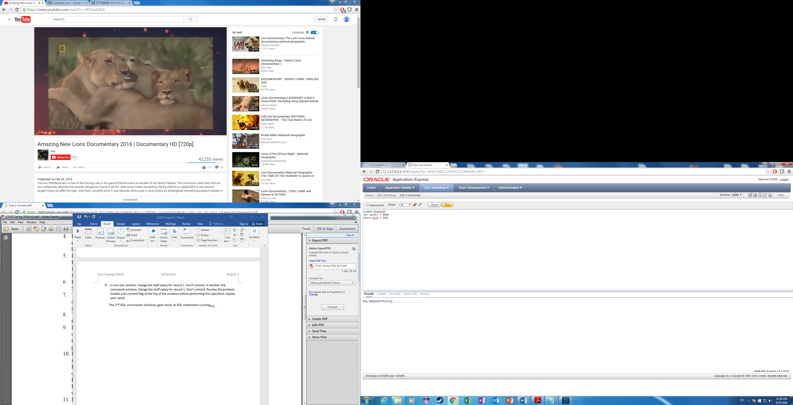

This problem can be solved by committing on the 1st SQL windows command. As soon you type commit on the 1st SQL window command the 2nd SQL windows command finishes the update.

1. In one SQL window, delete all drugs. Don’t commit. In another SQL window,

increase the price of all drugs by 5%. Don’t commit. Explain your results.

Resolve the problem. Create a backup of your table before implementing. To

create a backup table, enter CREATE TABLE <NEWTABLE> AS SELECT \*

FROM <ORIGINALTABLE>; COMMIT; Then you can rename a table using the

RENAME TABLE commit. Disable the auto commit flag at the top of the

windows before performing this operation.

When I tried to delete the drugs it would not let me because it says it violated constraint/ foreign key references. After I updated the price and tries to delete the drug again it says resource busy and acquire with no wait specified or timeout expired. Since I didn’t commit from the update of price it can’t get an lock to the drugs tables. A way to resolve this problem is to commit the price which releases the lock. To fix the deleting of the drugs I would have to not only delete the drugs but also all the foreign keys associated with the drugs’ primary key.

1. In one SQL window, null all patient addresses. Don’t commit. In another SQL

window, null all patient allergies. Don’t commit. Quit both Oracle sessions.

Login to Oracle and search for this information. Explain your results. Disable the

auto commit flag at the top of the windows before performing this operation

First I would have to make the address nullable because I made it not null. After I logged back into Oracle the addresses and patient allergies return to their original committed values. When I quit the Oracle database it didn’t commit for me.

1. Use the SQL DESCRIBE operation to list the table structure for all tables.

describe organizations;

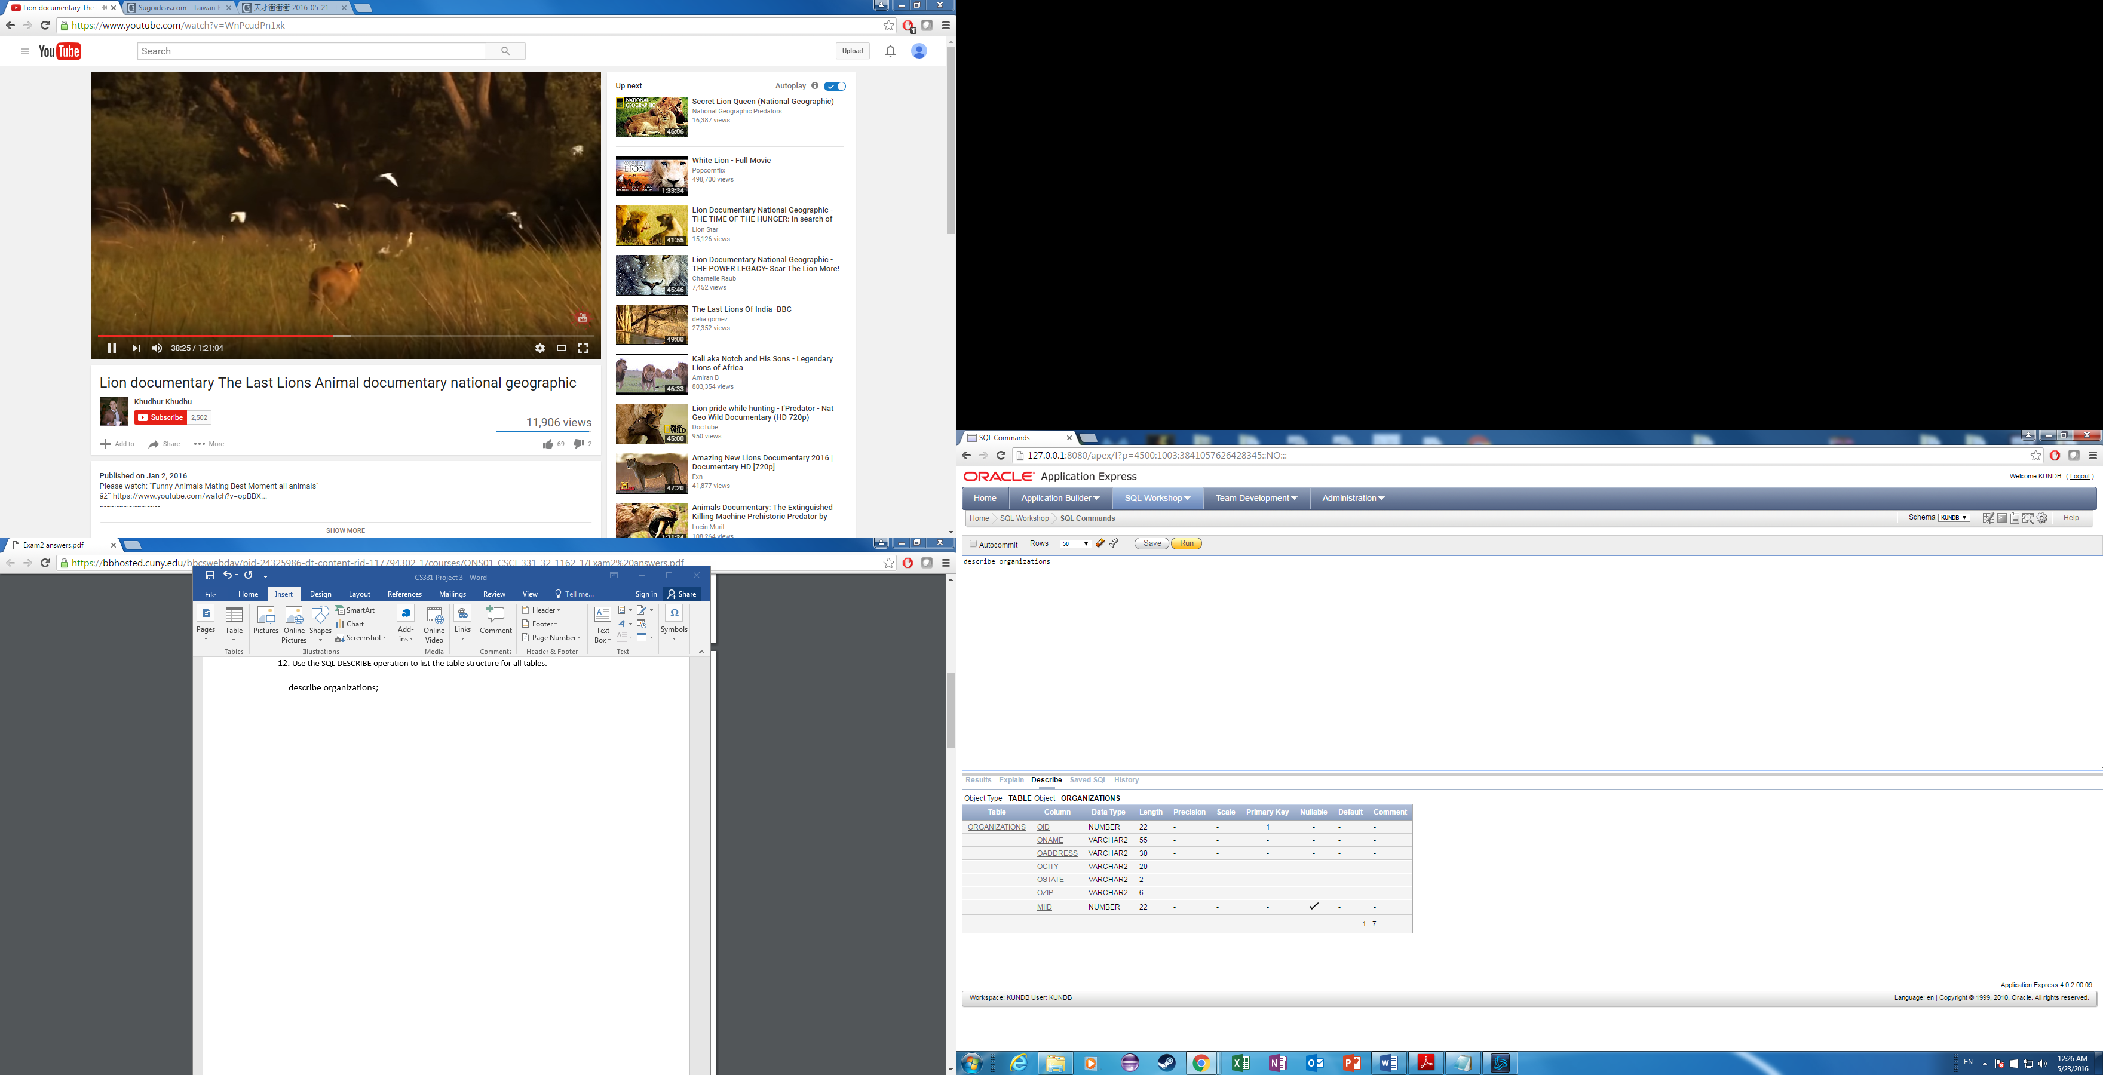

describe allergies

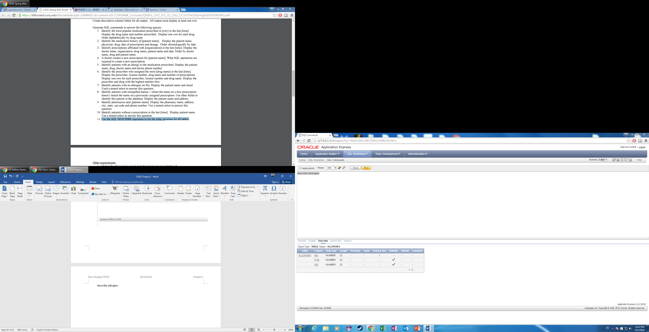

describe pharmacies

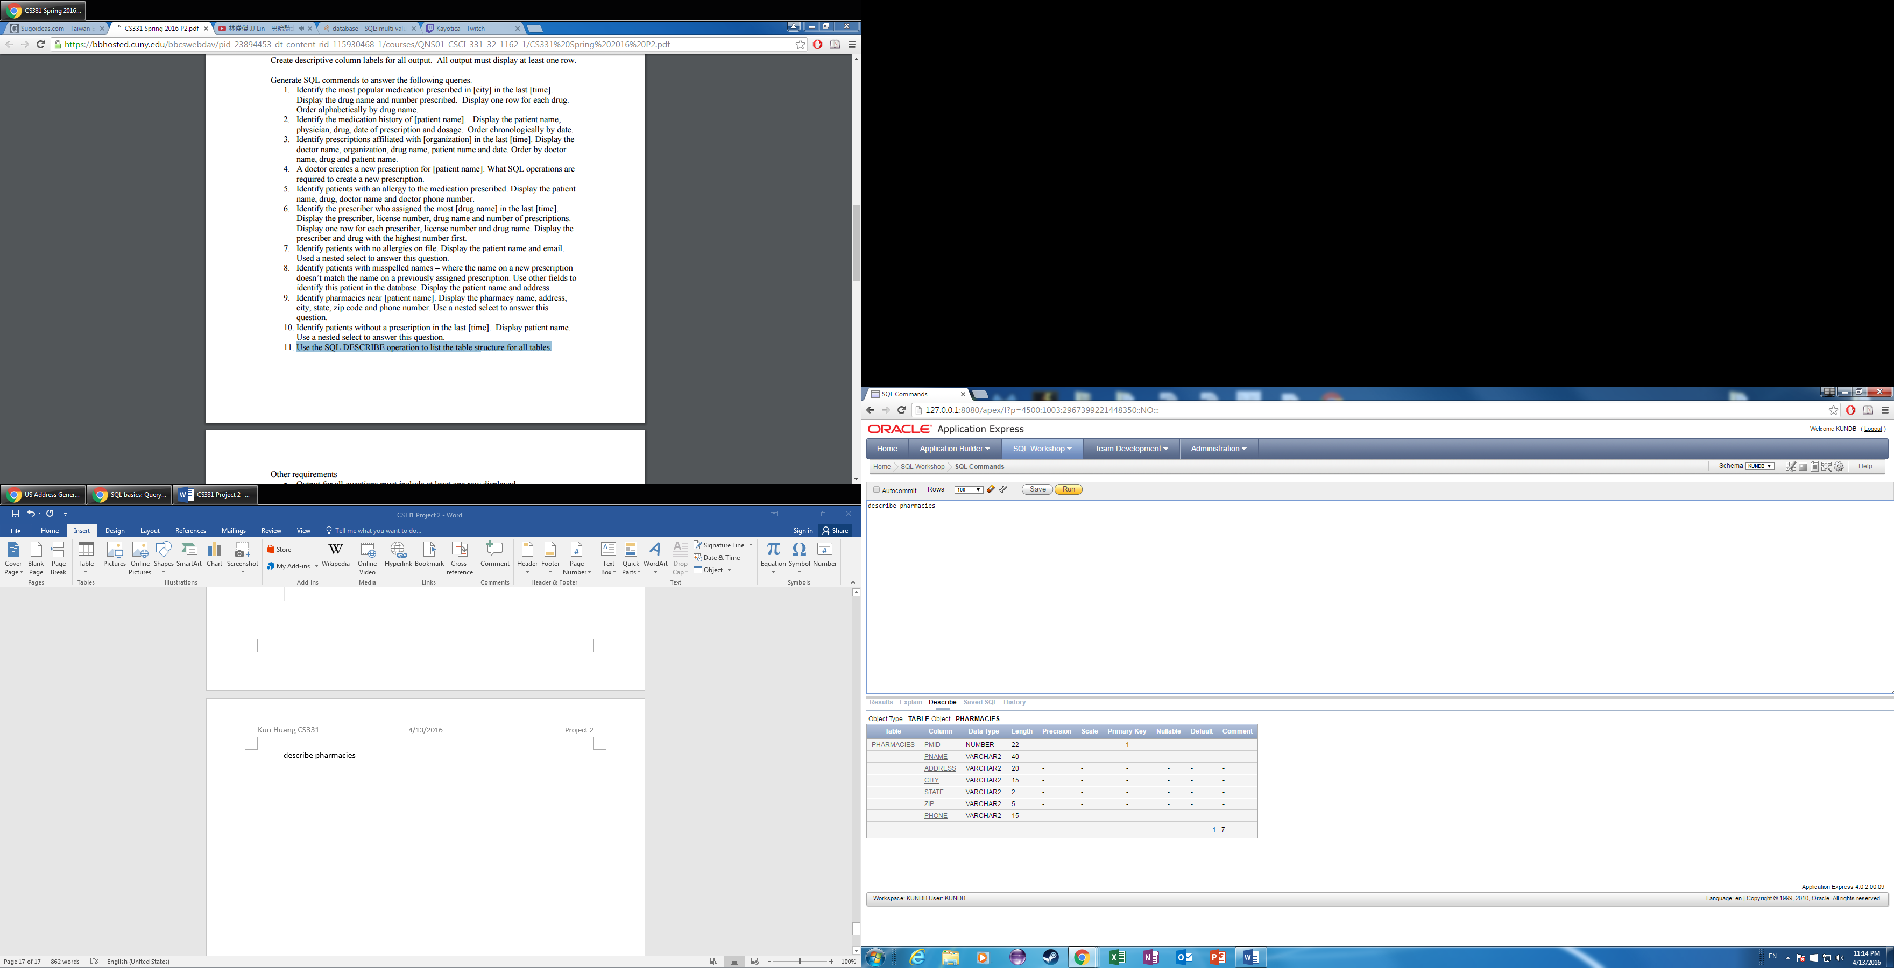

describe Patients

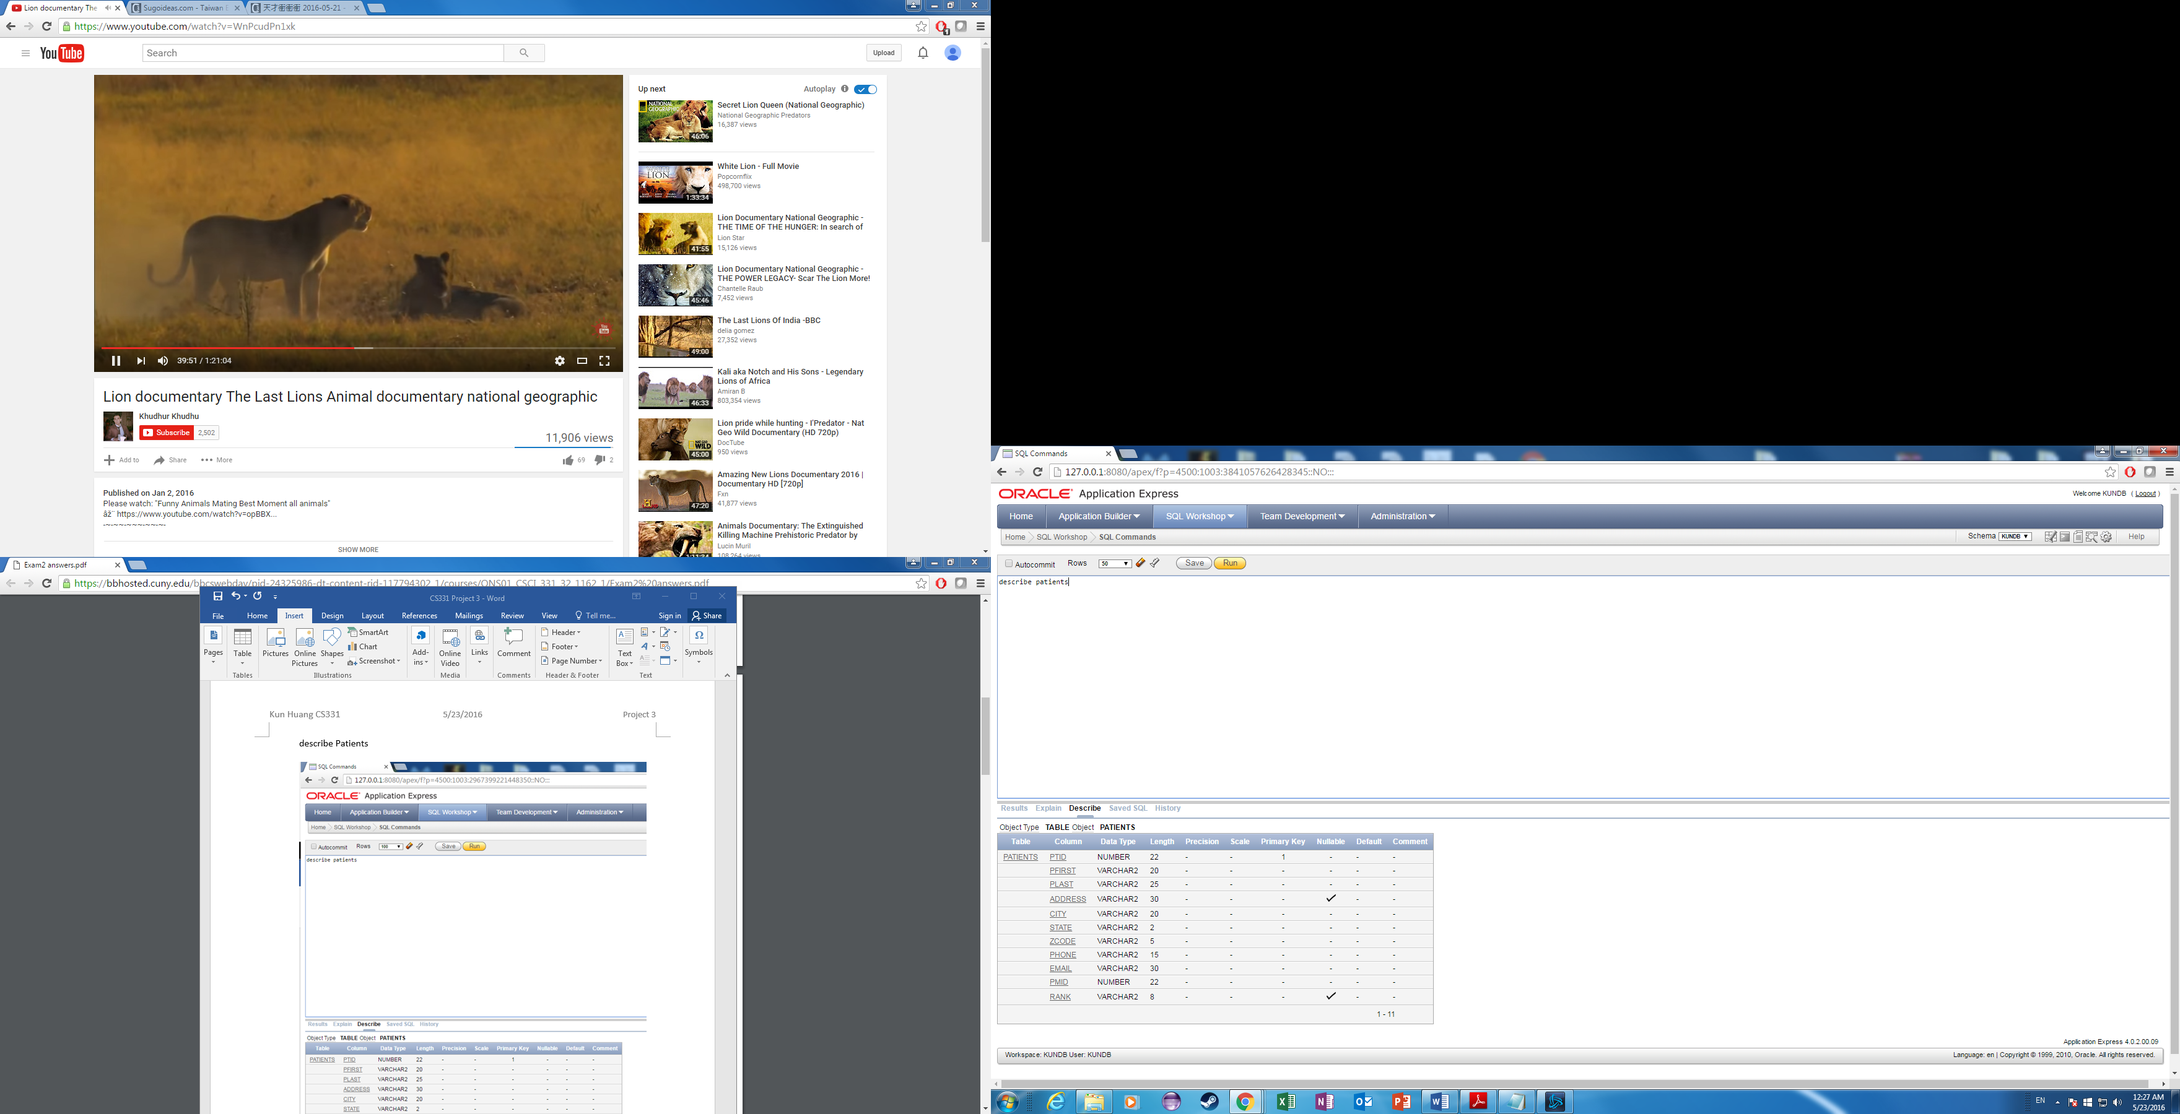

describe prescriptions

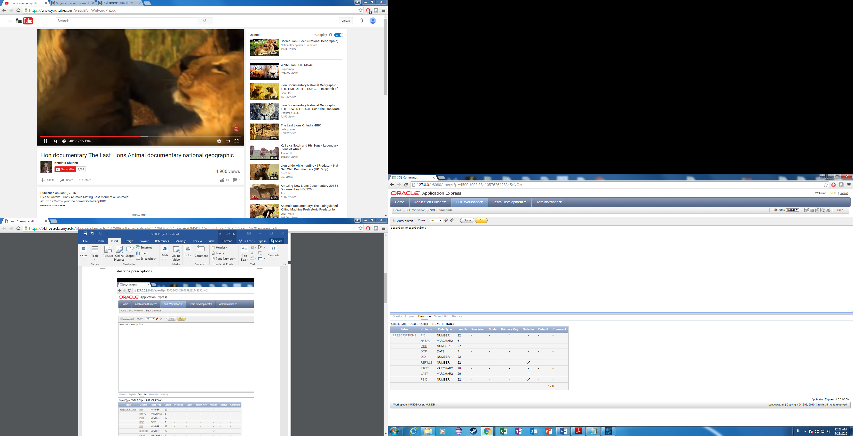

describe drugs

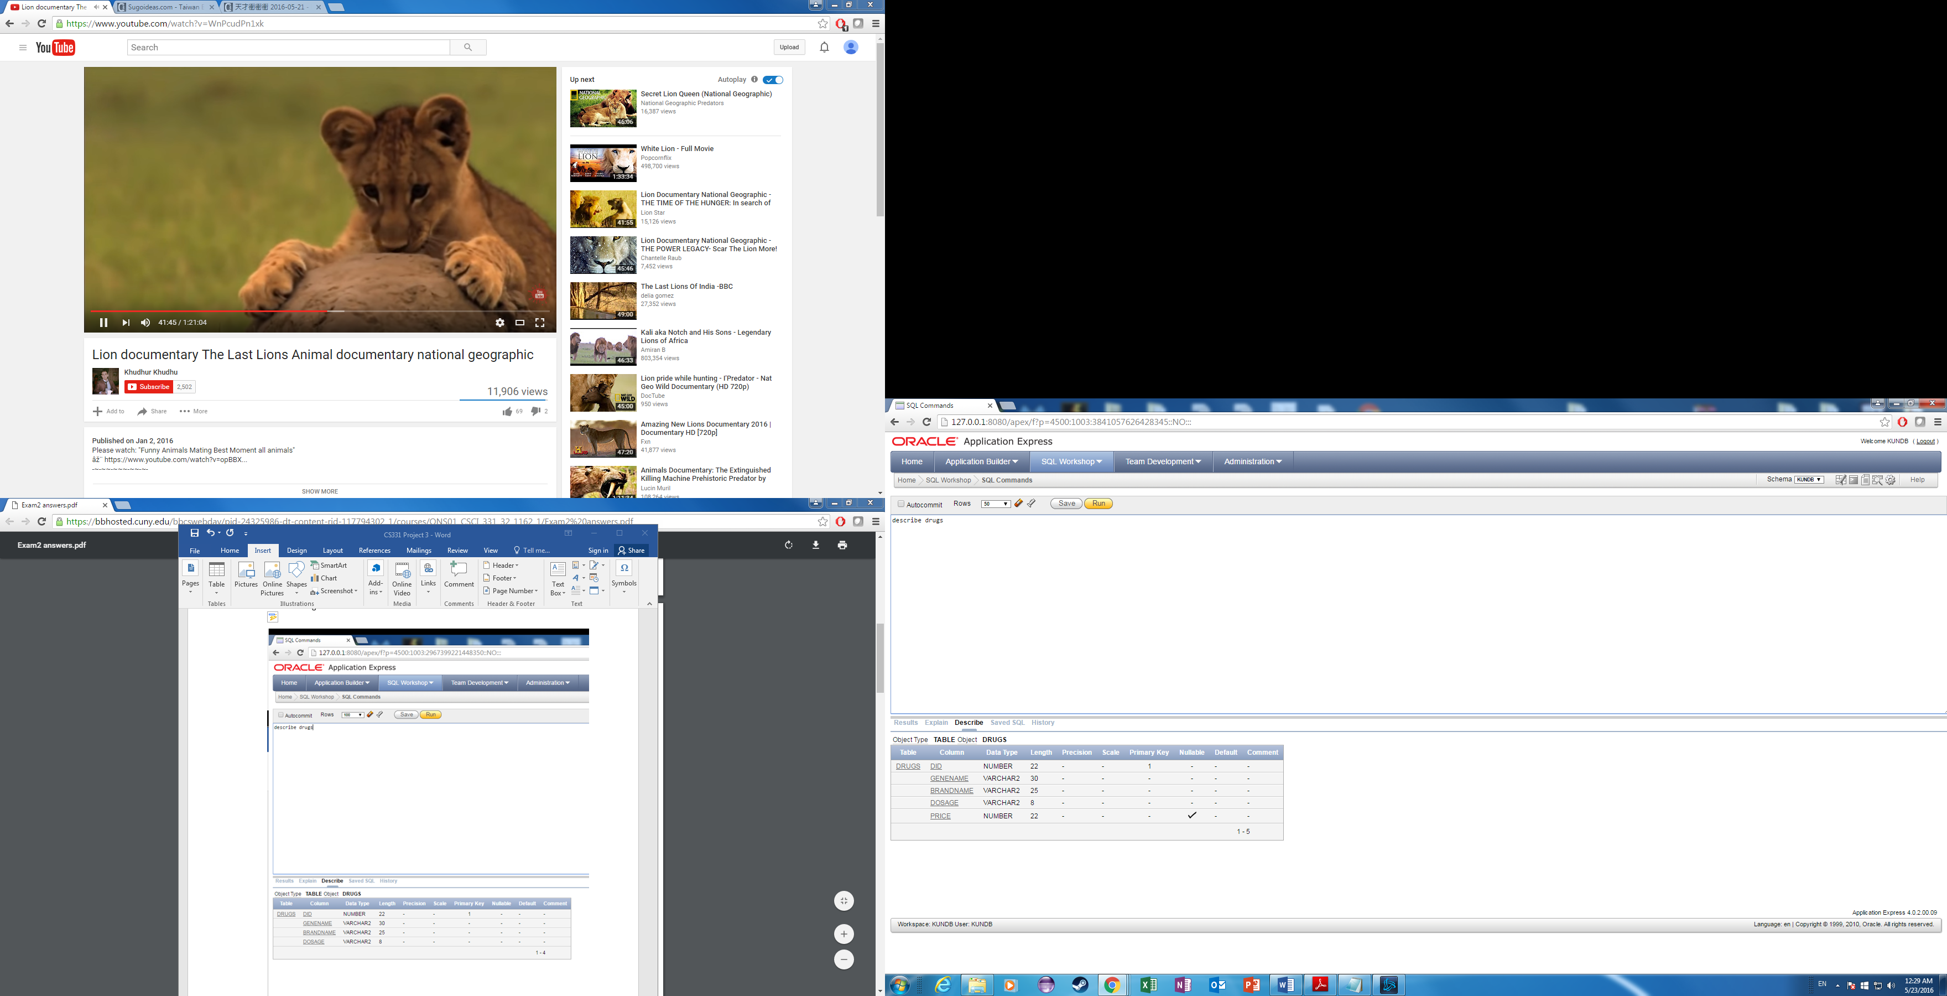

describe prescribers

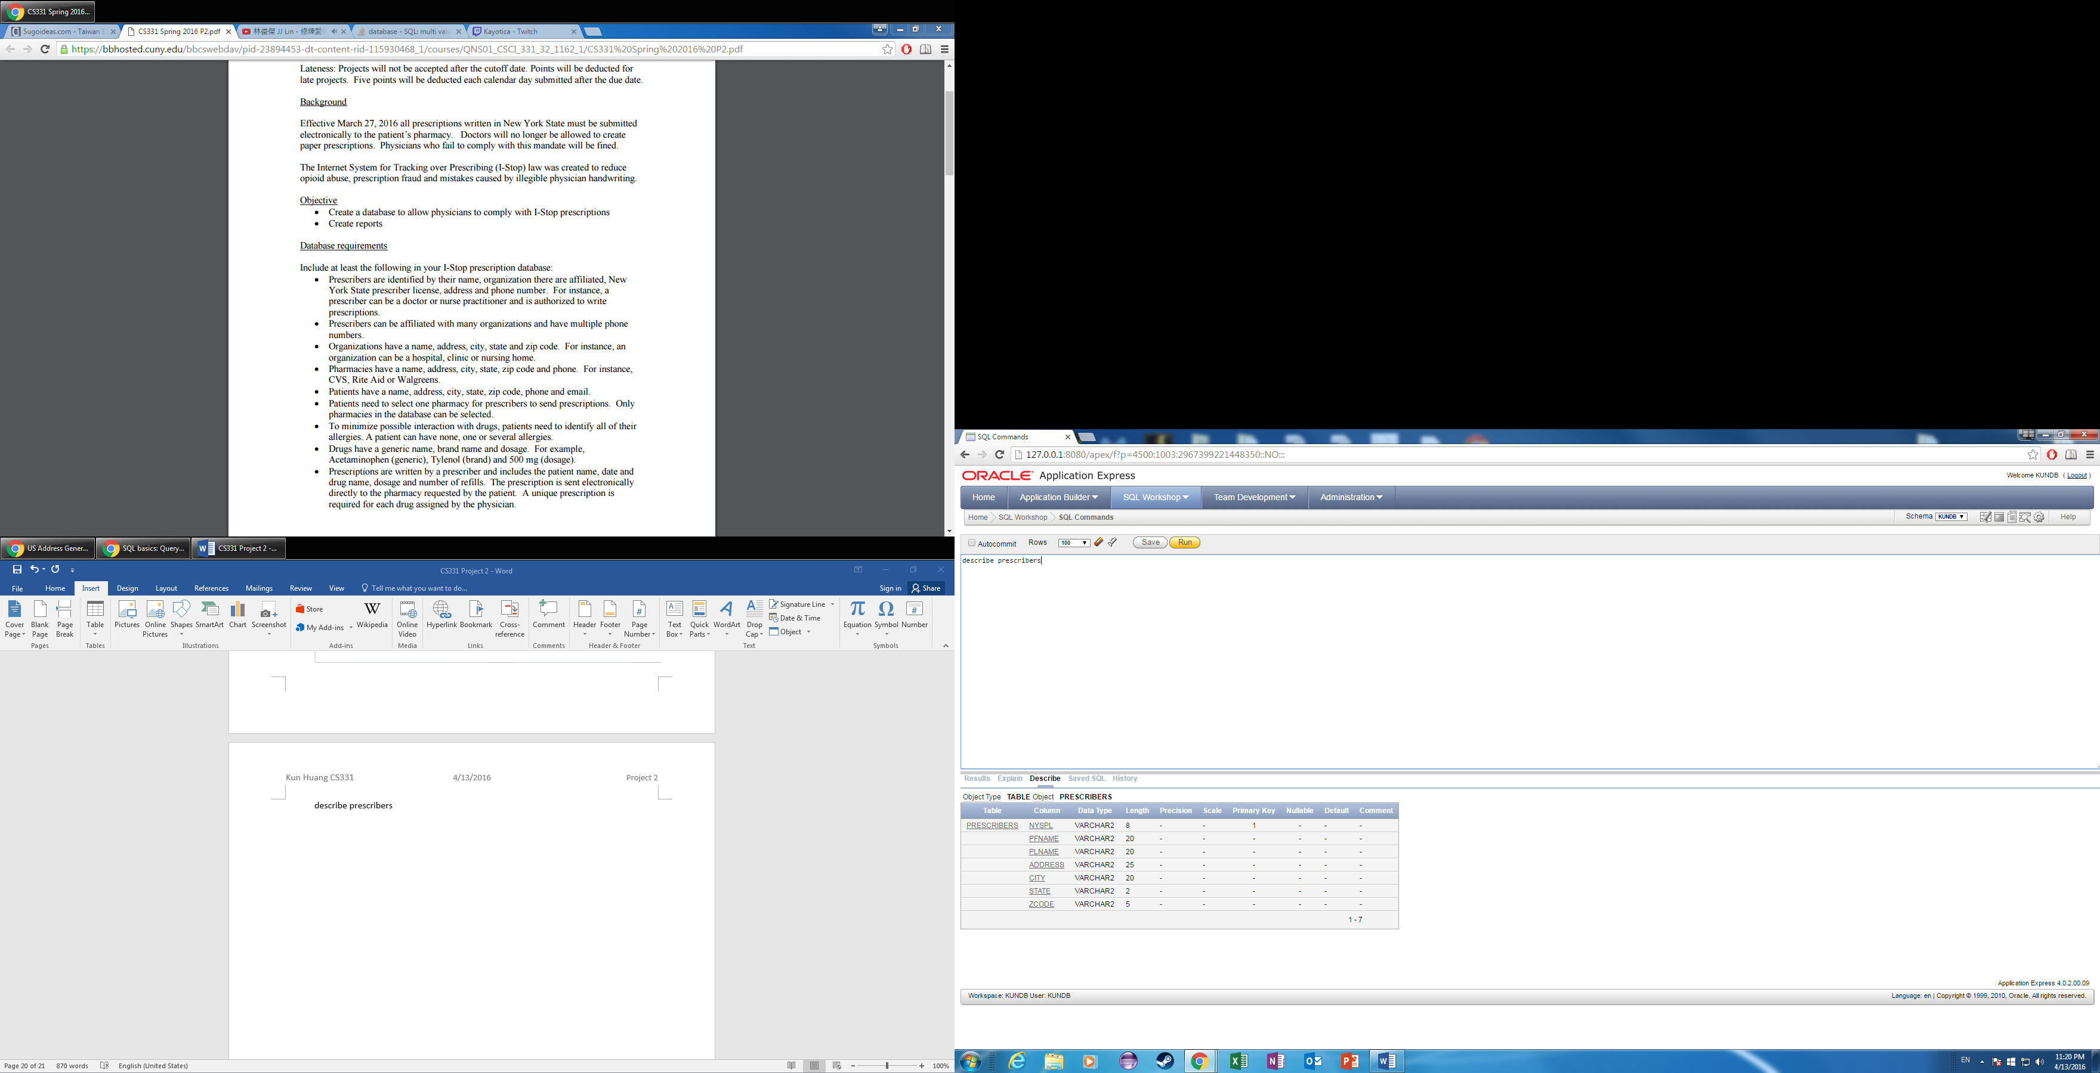

describe otype

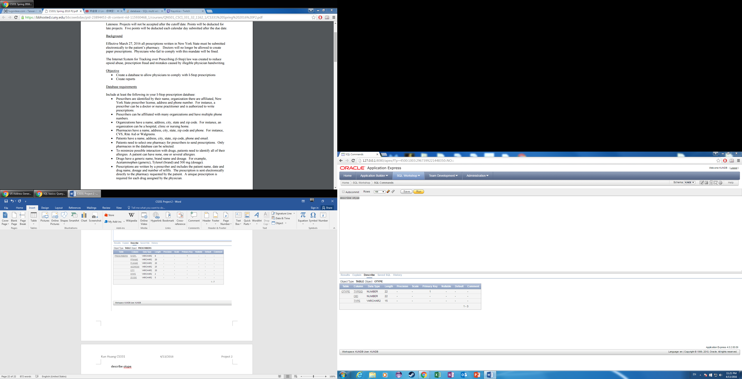

describe multiinfo

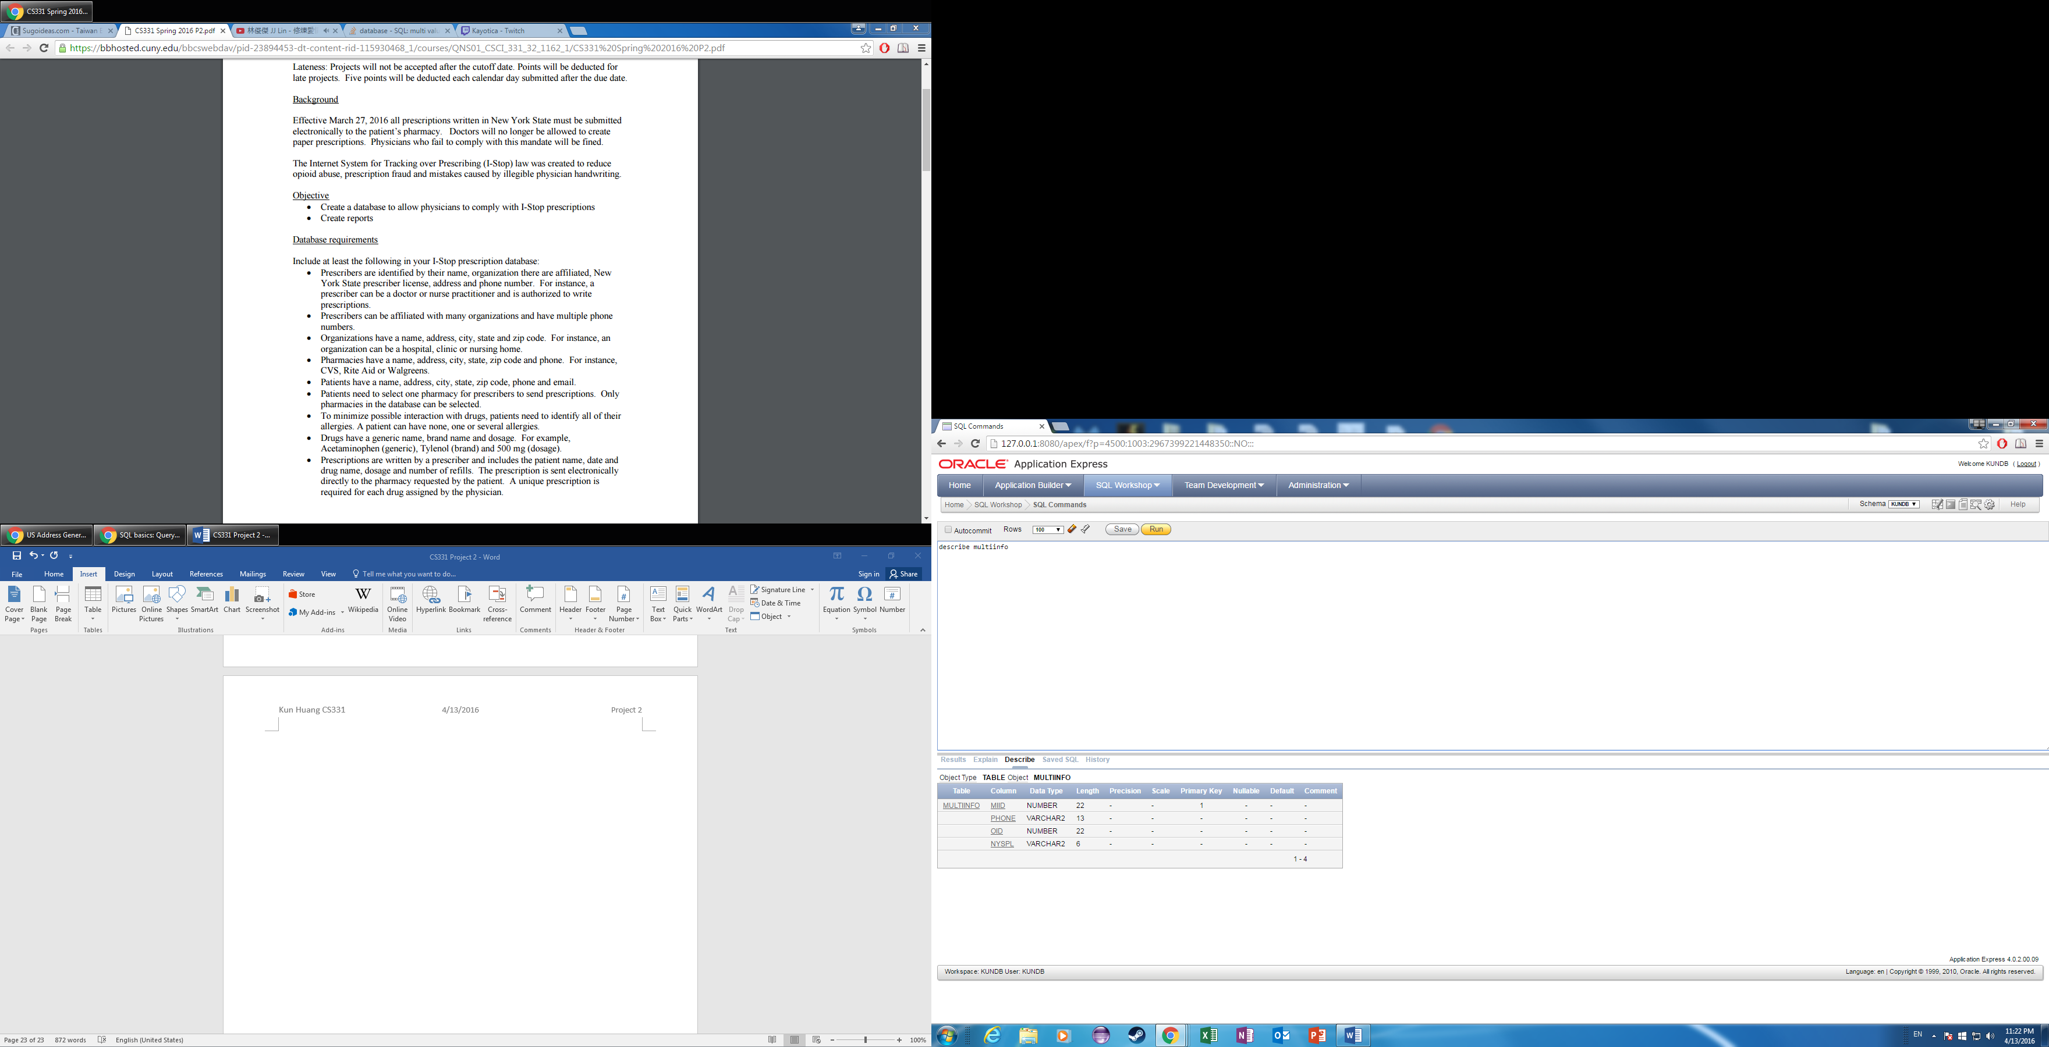

Describe phastaff

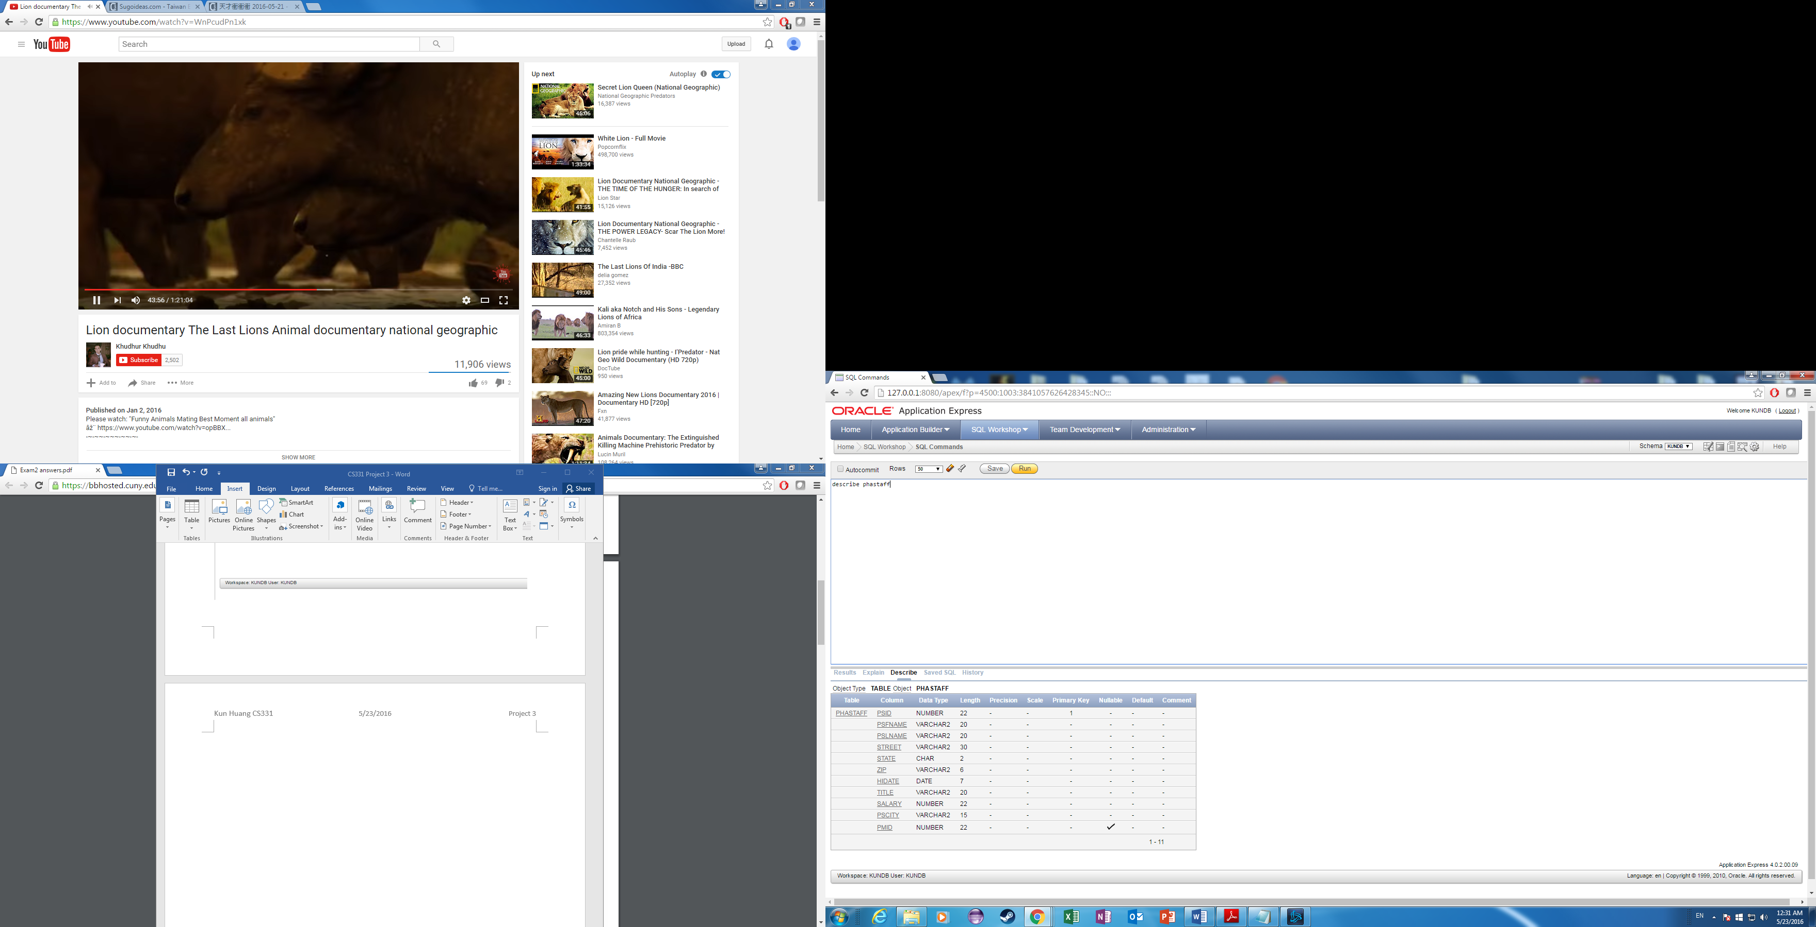

Describe parent

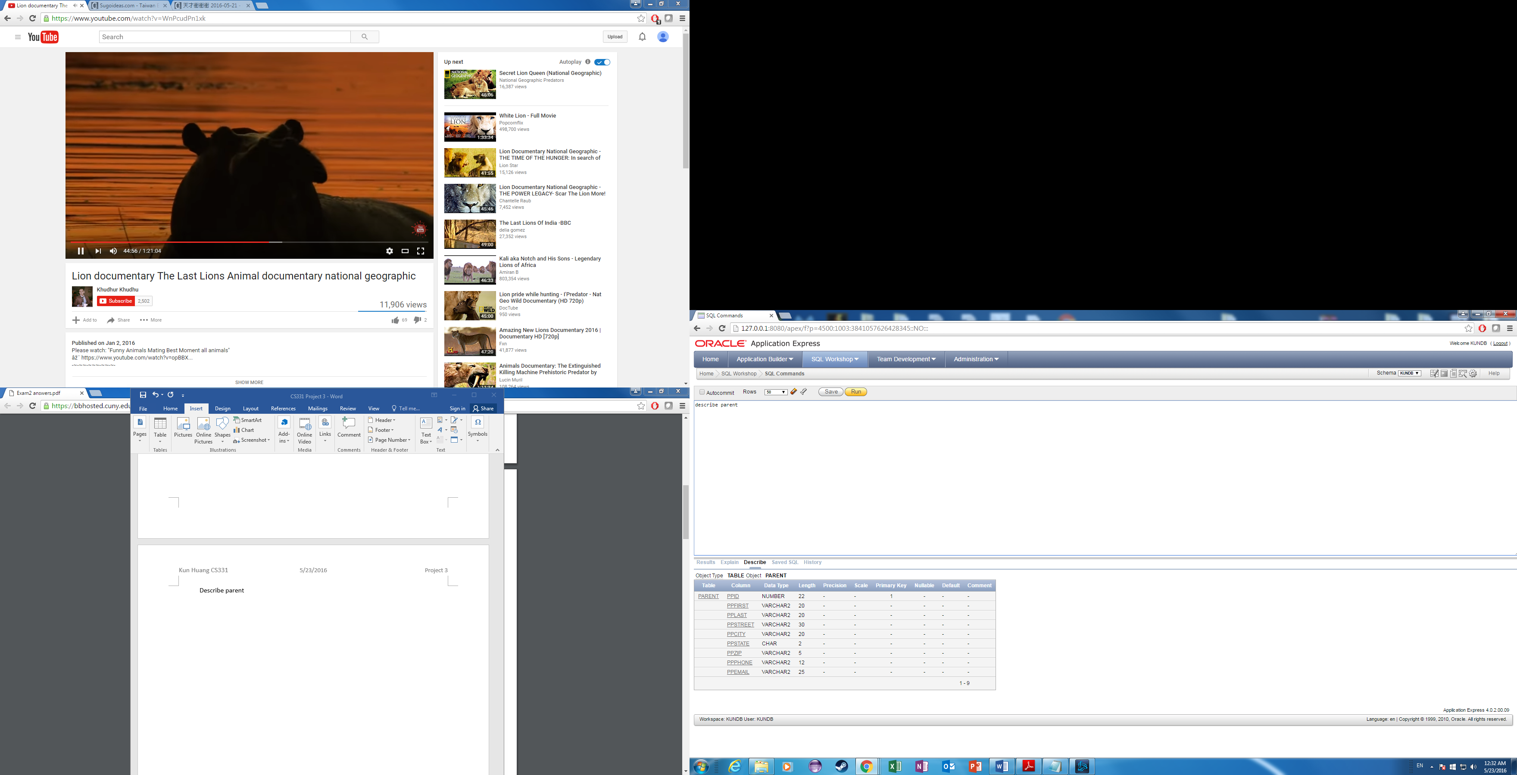

Describe parentchild

